ProjectDesignPhase-II

**DataFlowDiagram&UserStories**

|  |  |
| --- | --- |
| Date | 09May2023 |
| TeamID | NM2023TMID19171 |
| ProjectName | Automated weather classification using transfer learning |

DataFlowDiagrams:

A Data Flow Diagram (DFD) is a traditional visual representation of the information flows within a system. A neat and clear DFD can depict the rightamount of the system requirement graphically. It shows how data enters and leaves the system, what changes the information, and where data isstored.

Example:[(Simplified)](https://developer.ibm.com/patterns/visualize-unstructured-text/)

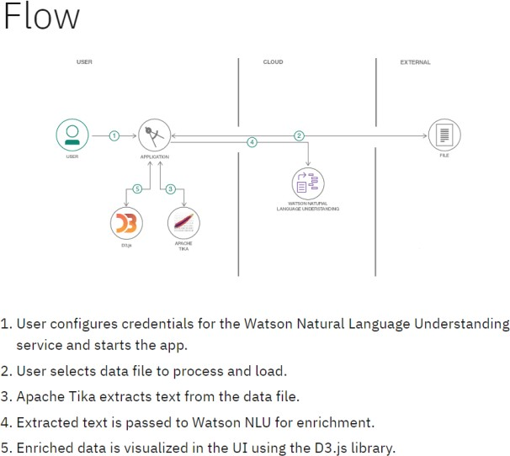

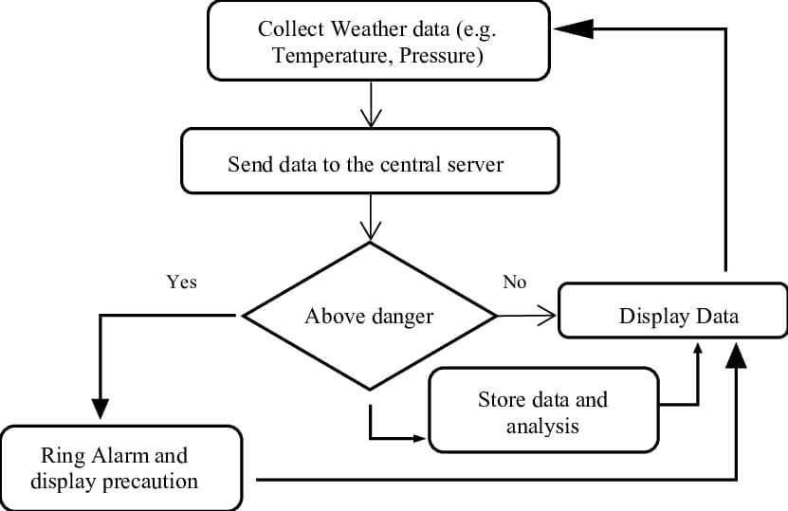

**DFD Diagram for automated weather classification using transfer learning**

**UserStories**

Usethebelowtemplatetolistalltheuserstoriesfortheproduct.

|  |  |  |  |  |  |  |
| --- | --- | --- | --- | --- | --- | --- |
| **UserType** | **FunctionalRequirement**  **(Epic)** | **UserStoryNumber** | **UserStory/Task** | **Acceptancecriteria** | **Priority** | **TeamMember** |
| Customer(Mobileuser) | Registration | USN-1 | Asauser,Icanregisterforthe applicationby  enteringmyemail,password,andconfirmingmypassword. | Icanaccessmyaccount/dashboard | High | Logesj |
|  |  | USN-2 | Asauser, IwillreceiveconfirmationemailonceI haveregisteredfortheapplication | Icanreceiveconfirmationemail&clickconfirm | High | Akash |
|  |  | USN-3 | Asauser,IcanregisterfortheapplicationthroughFacebook | Icanregister&accessthedashboardwithFacebook  Login | Low | Madhan |
|  |  | USN-4 | Asauser,IcanregisterfortheapplicationthroughGmail |  | Medium | Revathy |
|  | Login | USN-5 | Asauser,Icanlog intothe applicationbyentering email& password |  | High |  |
|  | Dashboard |  |  |  |  |  |
| Customer (Webuser) |  |  |  |  |  |  |
| Customer CareExecutive |  |  |  |  |  |  |
| Administrator | Manage theproduct | USN-6 | As a developer, I want to build a user-friendlyweb application that allows users to uploadimagesoftheirgarbageandreceivefeedbackonhowtosortitproperly. | We can detect weather classification using image. | High | Akash |
| Homeowner | Signin | USN-7 | As a homeowner, I want to be able to sort mygarbagemoreeffectively. | Allows for data to be gathered to build up a more detailed picture of a nation's climate, and trends within it. | Low | Logesh |
| MunicipalRecycling | Login | USN-8 | As a municipal recycling center employee, Iwanttobeabletoquicklyandaccuratelysort  incomingwastematerialsbytype. | Enables you to properly plan your farm operations, such as planting, irrigation, fertilizer application, pruning/weeding, harvesting or livestock mating | High | Madhan |

|  |  |  |  |  |  |  |
| --- | --- | --- | --- | --- | --- | --- |
| **UserType** | **Functional**  **Requirement(Epic)** | **UserStoryNumber** | **UserStory/Task** | **Acceptancecriteria** | **Priority** | **TeamMember** |
|  |  |  |  |  |  |  |
| WasteManagement | Dashboard | USN-8 | As a waste management professional, I wanttobe abletoautomaticallysortdifferenttypesof wasteusingcomputervision. | Accurate weather forecasting is critical in the agriculture industry. | High | Revathy |